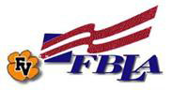
Benefits of
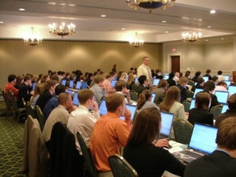
Competitions
Build useful skills that will benefit you in college or in the work force as you compete against students from around the state and nation
- Technology Skills
- Interviewing
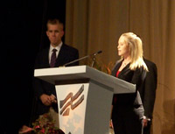
- Public Speaking
- Job Seeking Skills

Leadership Opportunities
Learn to plan, organize events, serve on committees and be a role model for peers.
- Lead, plan and coordinate Community Service Projects
- Organize groups for competitions
Community Service
Give back to our local community
- Volunteer in our local community
- Community Service Projects
  - RUFF (Rescue Ur Forever Friend)
  - (MMIA) Military Mission In Action

Network-
Meet and interact with students all over NC and USA.
- At Regional and State Conferences
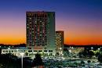
- At National Leadership Conference
Explore careers through partnerships with local businesses
- Internships with local businesses/groups
- Business Skills Workshops
- Volunteer Opportunities and Job Shadowing

Travel- National and State Leadership Conferences in Charleston SC, Greensboro, NC and Atlanta, GA
Scholarship Opportunities- Members can compete for numerous scholarships for college through FBLA and our business partners.

Discounts with FBLA membership
- FBLA-PBL has partnered with companies to provide hotel discounts, car rental discounts, shopping discounts, and other benefits. Go to National FBLA website http://bit.do/NsNRfor more information on FBLA membership benefits

Alamo Rent A Car  Amazon.com  Association Motor Club Marketing  Brainbench  Franklin Covey | GEICO  Hotel Discounts  HP  Men's Wearhouse  The Princeton Review

